personal diary

CP Lab Project

Sir Mohsin Javed

BAHRIA UNIVERSITY ISLAMABAD CAMPUS

Ayesha Batool

Aml Abdul Qadir

# FINAL PROJECT REPORT

# 1. Introduction

The Personal Diary Application is a C++ program designed to allow users to securely enter, search, display, edit and delete diary entries. This project was developed as a semester project, incorporating file handling, user authentication, and basic text processing.

# 2. System Design

The system design is structured around a command-line interface with the following functionalities:

* User authentication
* Menu-driven interaction
* Entry management (add, search, display, edit)
* **DIAGRAMS**

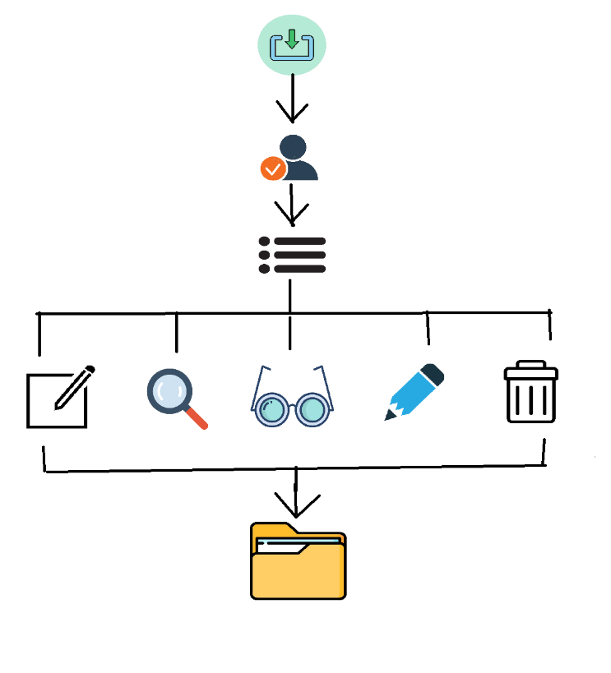

# 3. Evaluation

The project successfully implements a functional personal diary application with the following features:

1. Secure Access: The diary is protected by a password.
2. User Interaction: The menu system allows users to interact with the diary easily.
3. File Handling: Entries are stored, retrieved, edited, and deleted from a text file.
4. Flexibility: Users can enter dates manually, allowing for more flexibility in managing entries.

# Implementation

## Login function

The “login” function prompts the user for a password and validates it. The password is hardcoded as "password" for simplicity.

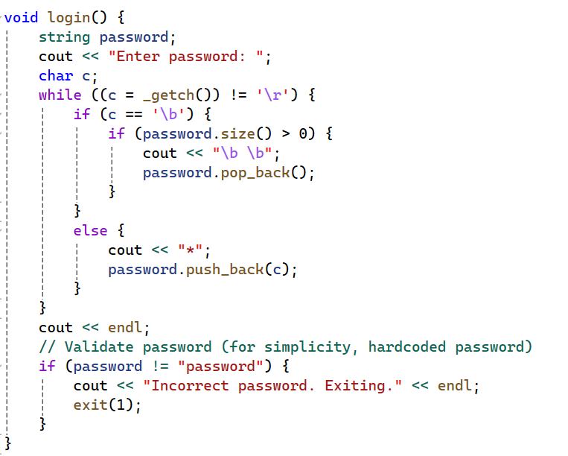

### Menu function

The “displayMenu” function presents the user with a menu of options to interact with the diary.

### 

### Enter Entry Function

The searchEntry function allows the user to search for entries by date or keyword.

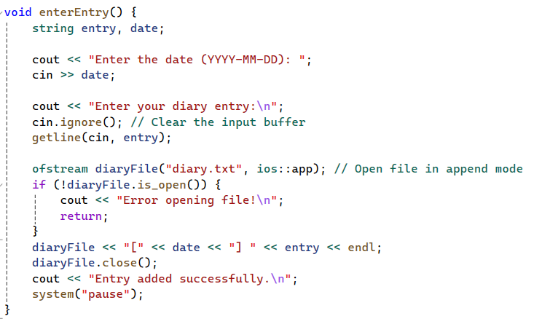

### Search Entry Function

The “searchEntry” function allows the user to search for entries by date or keyword.

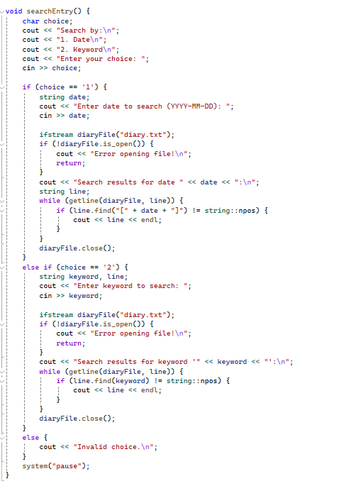

### Display Entry Function

The “displayEntry” function displays all entries stored in the diary.txt file.

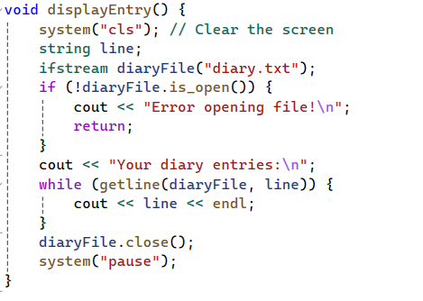

### Edit Entry Function

The “editEntry” function allows the user to edit an existing entry by date.

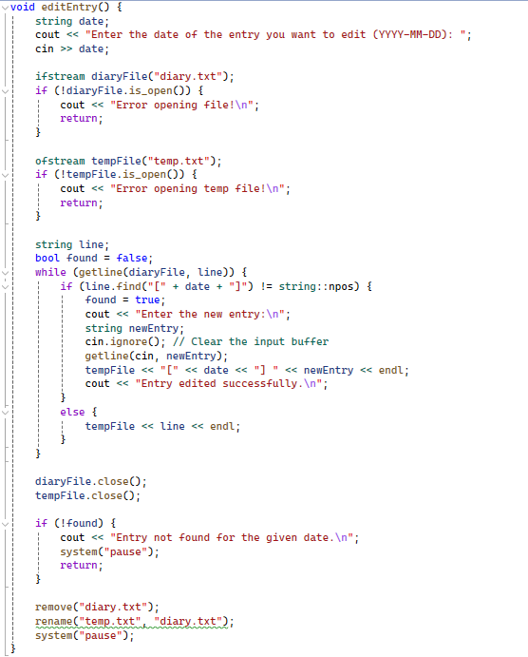

### Delete Entry Function

The “deleteEntry” function allows the user to delete an entry by date.

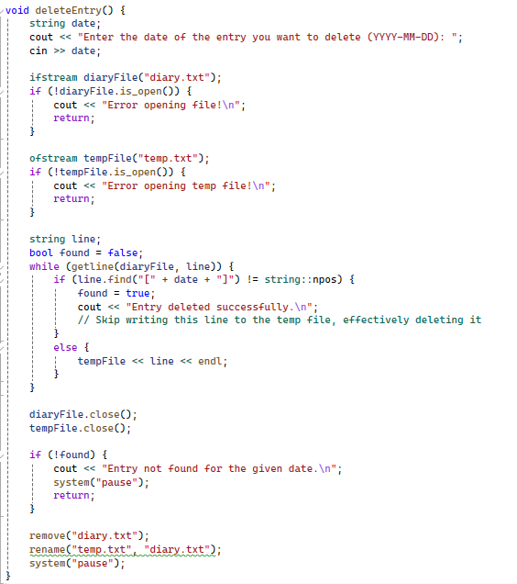

# 5. Conclusion

This project demonstrates the practical application of file handling and user interface techniques in C++. The diary application is a useful tool for personal record-keeping, and the project provides a solid foundation for further enhancements, such as adding encryption for entries or a graphical user interface.